PRESS RELEASE

Martinez Historical Society
PO Box 14 (1005 Escobar Street)
Martinez, California

Date: September 21, 2016

Contacts: Carolyn Boone Duncan
Email: cfboone@aol.com
Telephone: (925) 864-8457

John Curtis
Email: CurtisJD@ix.netcom.com
Telephone: (925) 957-1000

The Historic Home Tour in Martinez

Returns on Saturday Oct. 8th

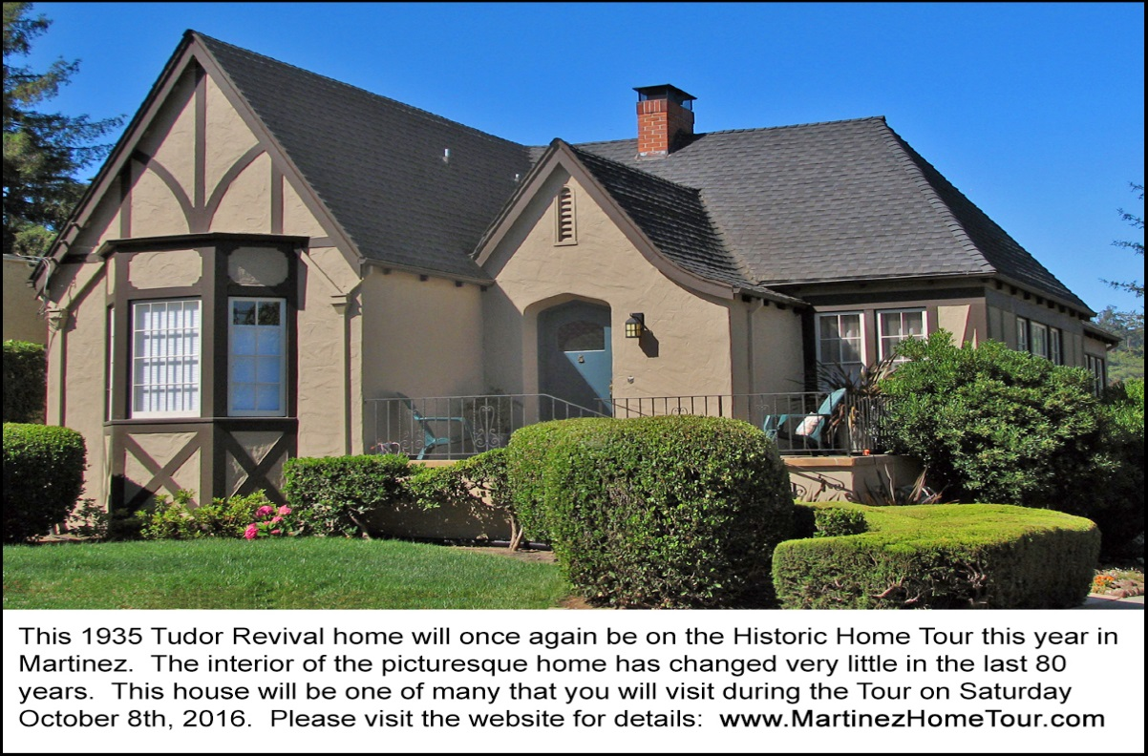
This 1935 Tudor Revival home will be one of seven houses on the 2016 Historic Home Tour in Martinez.
The owner of this house has been very diligent in preserving the home just as it was built 81 years ago.

MARTINEZ. The 10th annual Historic Home Tour in Martinez will take place on Saturday, October 8th from 10am to 4pm. There will be seven (7) private homes open to the public – most for the first and ONLY time. The Tour is organized each year by the Martinez Historical Society to focus attention on the town’s unusually large collection of vintage homes constructed over the last 150 years.
This year’s Tour will feature homes located southeast of Downtown Martinez. The historic home styles are primarily American Craftsman and Tudor Revival. These homes were constructed during the 1914 to 1949 period.
Each house reflects the personalities of the homeowner. For example, there is a 1914 Craftsman bungalow which the owner restored to its appearance of 102 years ago – and then added a model train which chugs around the living room (at the level of the picture rail) when the front door is opened. Another homeowner incorporated two of the Gargoyle lights from San Francisco’s 1906 Beaux-Arts Monadnock Building into his home -- which also has an impressive Art Deco interior. Then there is a 1934 Tudor Revival home which contains a feature rarely found in California: an original 1930s kitchen in wonderful condition that has never been updated.
As in past years, the Shell Clubhouse at 1635 Pacheco Boulevard in Martinez will be the starting point for the Tour. The 1937 Clubhouse is itself an historic structure that was built by the Shell Refinery in the Arts & Crafts style. Visitors arriving at the Clubhouse will be offered complementary coffee. They will also find interesting booths that have been set up by local organizations such as the John Muir National Historic Site, the local Genealogical Society and others.
There will also be special exhibits set up in the Clubhouse for the day of the Tour. Since this is an election year, there will be an impressive display of vintage political memorabilia dating all the way back to the Grover Cleveland Administration in the 1880s. A companion exhibit will feature 20th Century press cameras -- and camera models used by past presidents, first ladies and other politicians. The exhibit will include photos of these well-known personalities and the same camera models that will be on display in the Clubhouse.
More exhibits can be seen in the adjacent Shell Museum which is operated by Shell Alumni (retired refinery employees). The Museum has its own displays that relate to the history of petroleum processing and to the Shell Martinez Refinery itself (constructed in 1915).
For those who don’t wish to drive their own cars, buses will depart from the Clubhouse every 10 minutes to shuttle visitors onward to the homes that will be on the tour. There will be knowledgeable tour guides on the buses. There will also be docents in each home to welcome visitors, point out the features of the houses, and to answer questions.
There will be a special treat for tour goers this year: a visit to a wonderful garden where wildlife are rescued and rehabilitated. The homeowner coordinates her efforts with those of the Lindsay Wildlife Museum. The wild animals in her garden are curious about human visitors instead of afraid.
Also on the Tour will be the Martinez Junior High School. Built in the Spanish Revival style, the 1931 building won a state-wide architectural award. Tour goers will see several of the original interior features which were left preserved during the 1968 seismic retrofit and a later renovation that took place in 1999.
The Martinez Museum is also on the Tour route. “The Museum has been closed for the last 12 months while undergoing renovations,” reports John Curtis, the Martinez Historical Society President “but the Tour will allow visitors to see the restored interior of the building and all the new displays before the Museum officially reopens to the general public a week later.”
“Each year’s Tour is different, “said Carolyn Duncan, Chair of the Home Tour Committee, “And we’re confident that this year’s Tour – with its highly personalized homes, antique automobiles, the wildlife sanctuary, the museums and a number of local musicians -- will provide tour goers with a memorable visitor experience.”
Home Tour tickets are $25 in advance and $30 at the door. Tickets can be purchased by credit card at www.martinezhometour.com or www.eventbrite.com. Tickets can also be purchased with cash or check at four Martinez stores: Char’s Flowers (635 Main Street), Peirano Jewelers (510 Center Avenue),), The UPS Store (Lucky Shopping Center) and I’ve Been Framed (411 Ferry Street).
The Historical Society thanks the following sponsors who make this tour possible:
Shell Martinez Refinery, Cole Real Estate, West Berkeley Design Loop, Shell Chemical Company, Republic Services, Shell Western States Federal Credit Union, Hagin’s Automotive, Bisio/Dunivan, Les Schwab Tire Center of Martinez, Ecomulch, Community Focus, City of Martinez, Leading Edge Pest Management, Schroder Insurance, Connolly & Taylor Chapel and Michael Briones of J. Rockcliff Realtors.

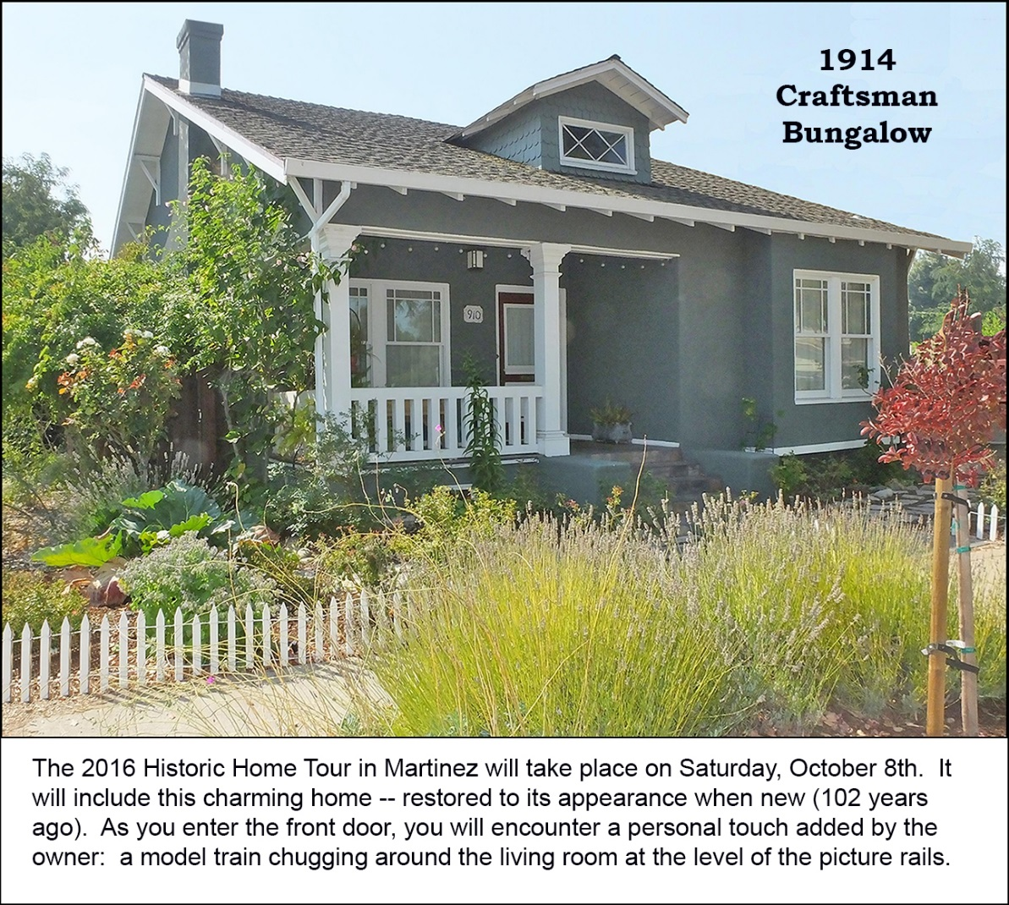
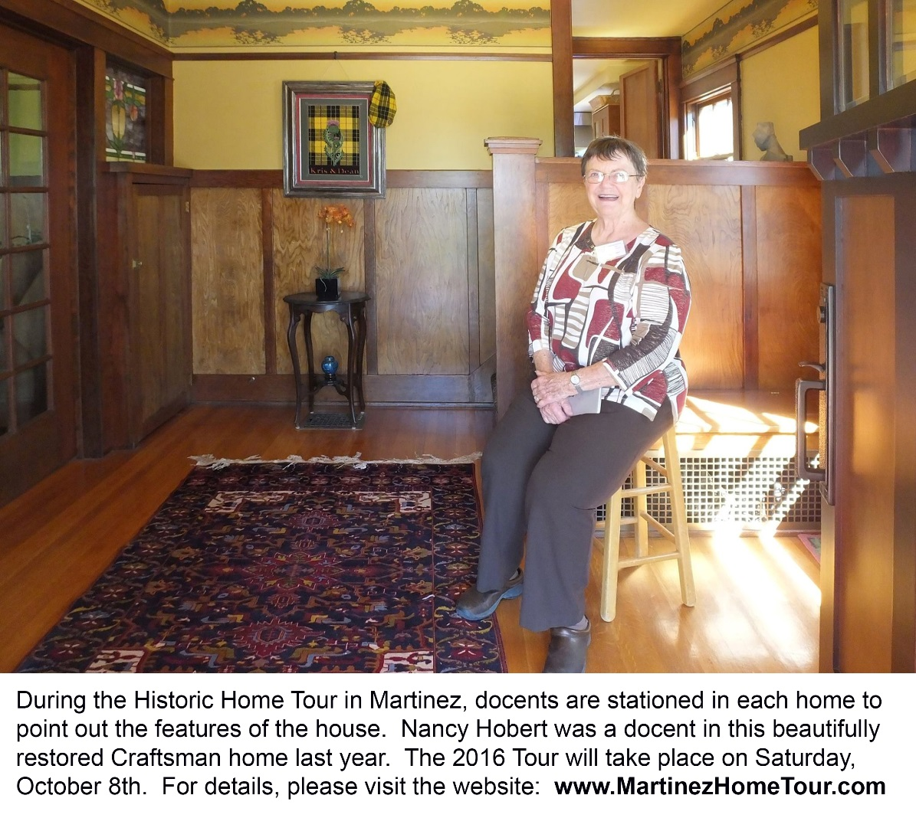

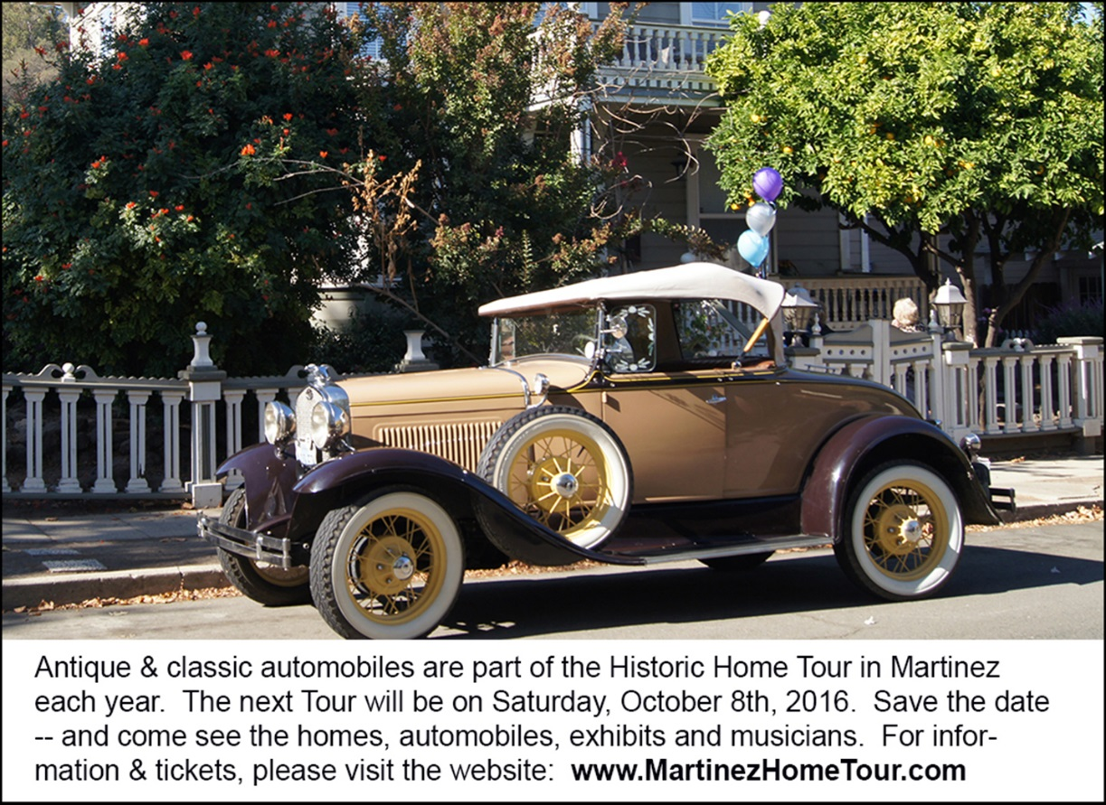

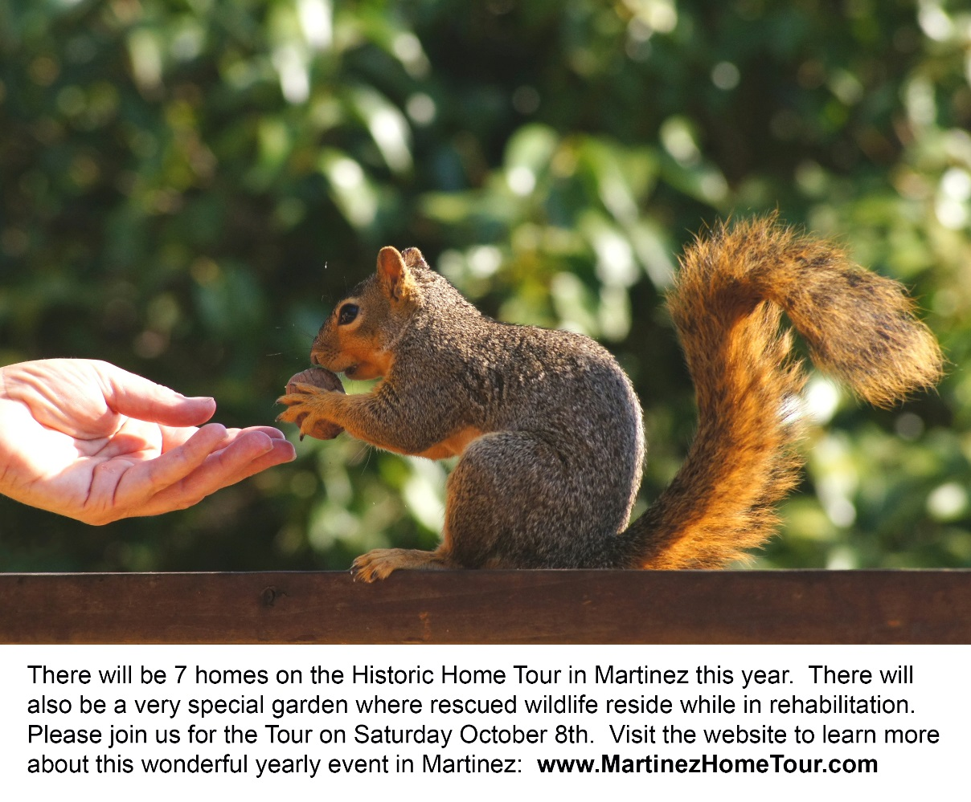

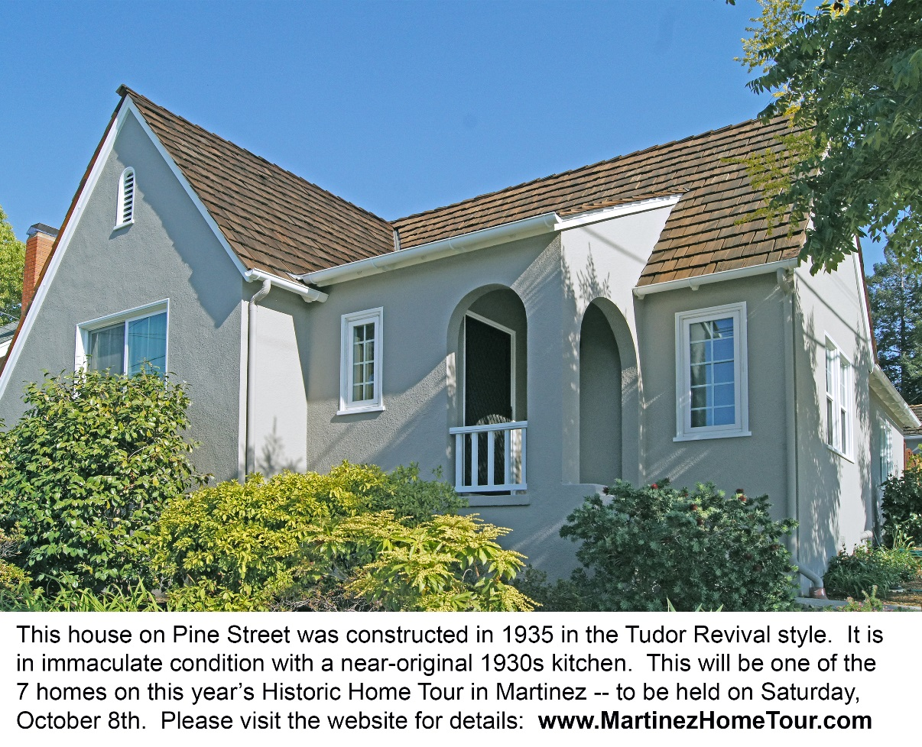

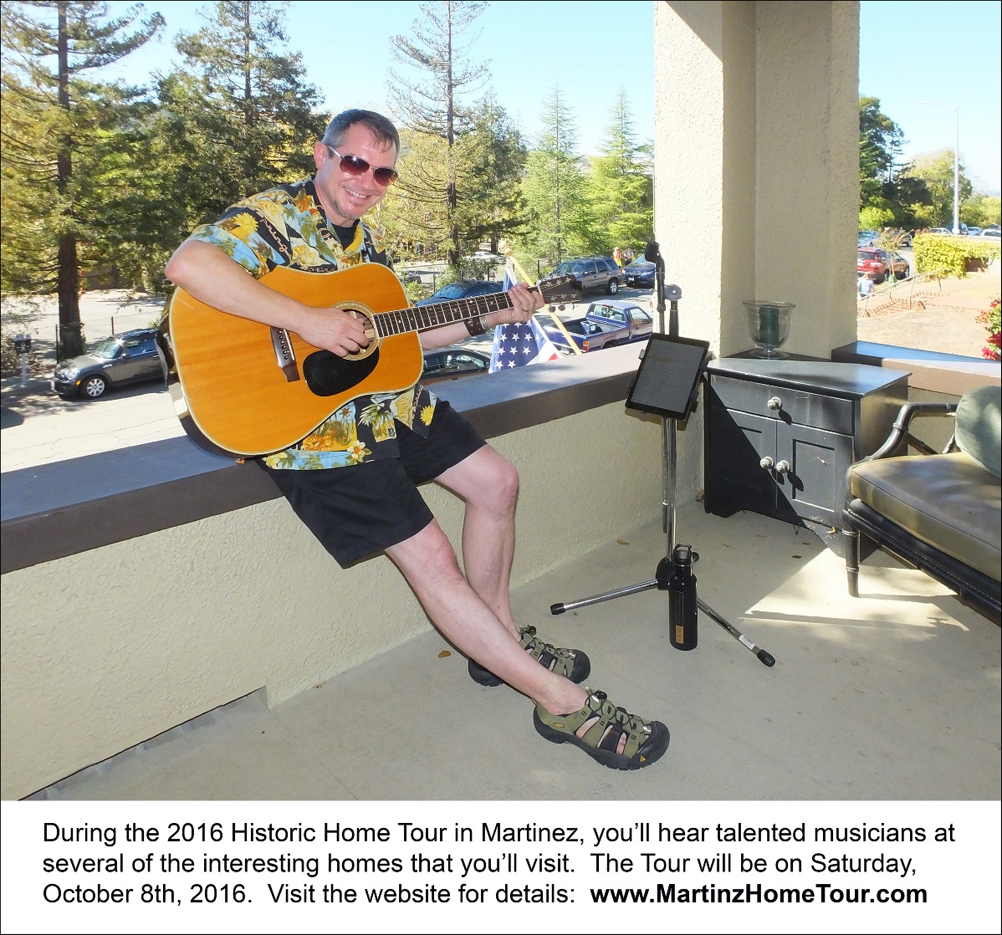
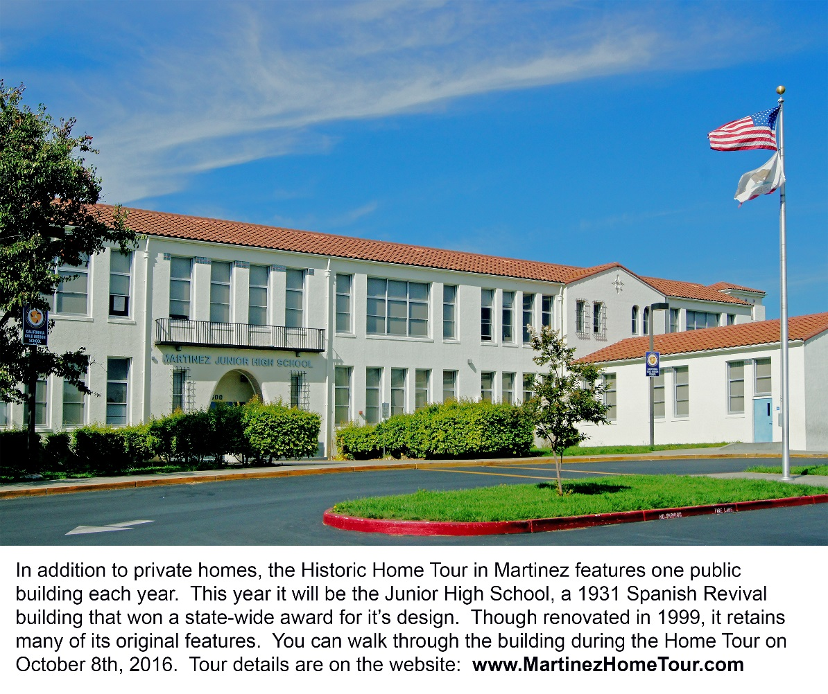

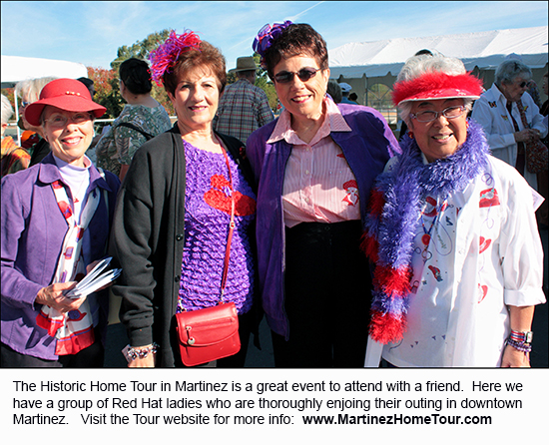
Note to editor:
- To see more Home Tour photos, please click here: press materials

